4. DNB GP IS Compliance for Log360

Tagline – Achieve DNB GP IS compliance with automated log collection and audit reporting using Log360.

Overview: The DNB GP IS Compliance extension for Log360 helps organizations align with the Dutch central bank's DNB GP IS guidelines. By integrating this extension, IT and security teams gain comprehensive visibility into their information security posture.
Log360 continuously collects and correlates log data from Active Directory, Windows, Unix/Linux, Microsoft 365, cloud platforms, and network devices, mapping events directly to DNB GP IS requirements. Security teams can track compliance status in real time, investigate incidents quickly, and generate audit-ready reports with a single click.

Key Features:
- Generate comprehensive audit-reports mapped to each of the DNB GP IS information security controls.
- Correlates logs from different sources to detect threats, anomalies, and suspicious activities with automated rule sets.
- Provides powerful search capabilities with filters, keywords, and time-based queries for rapid incident investigation.
- Export reports in PDF and CSV format for auditors, management, or regulatory submissions.

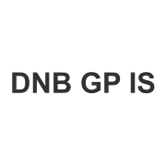

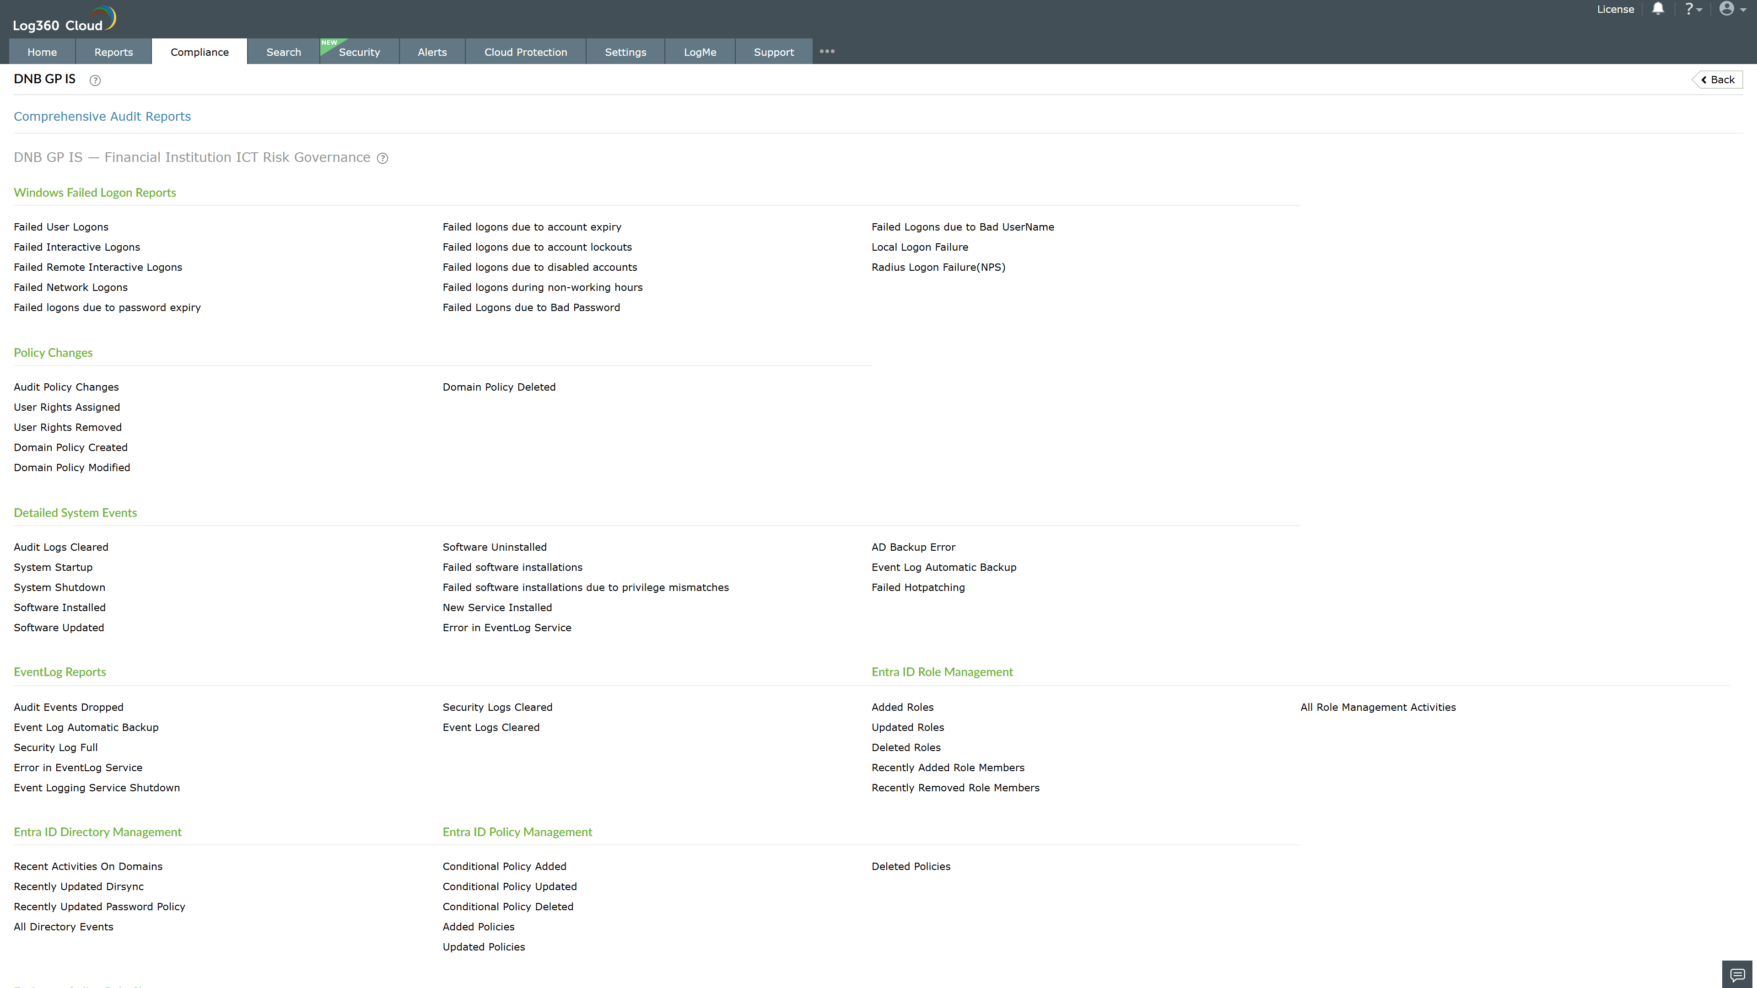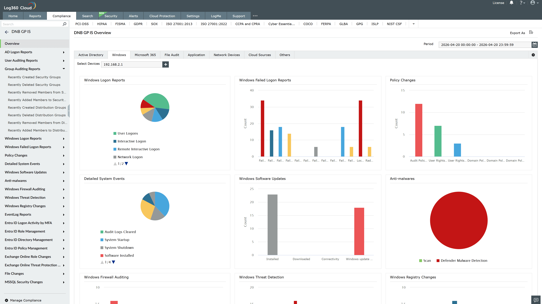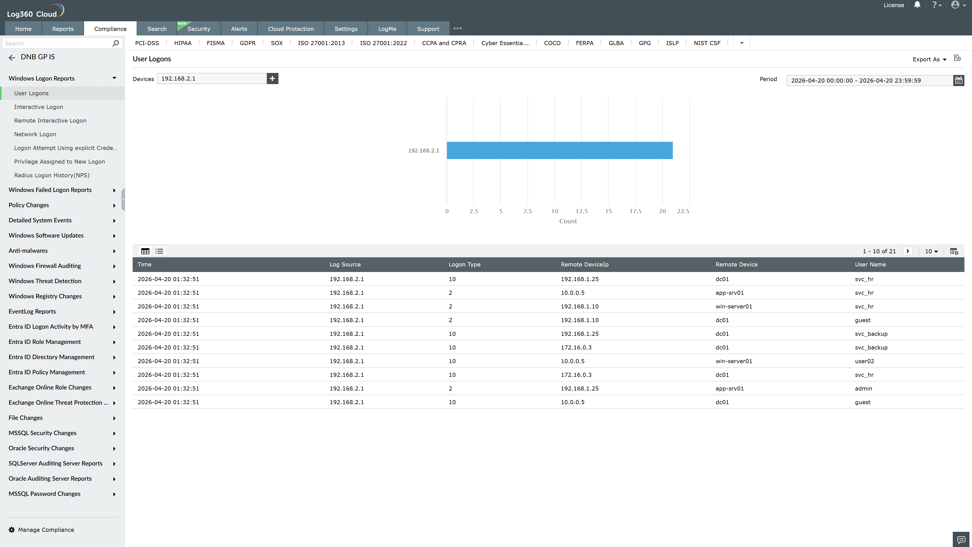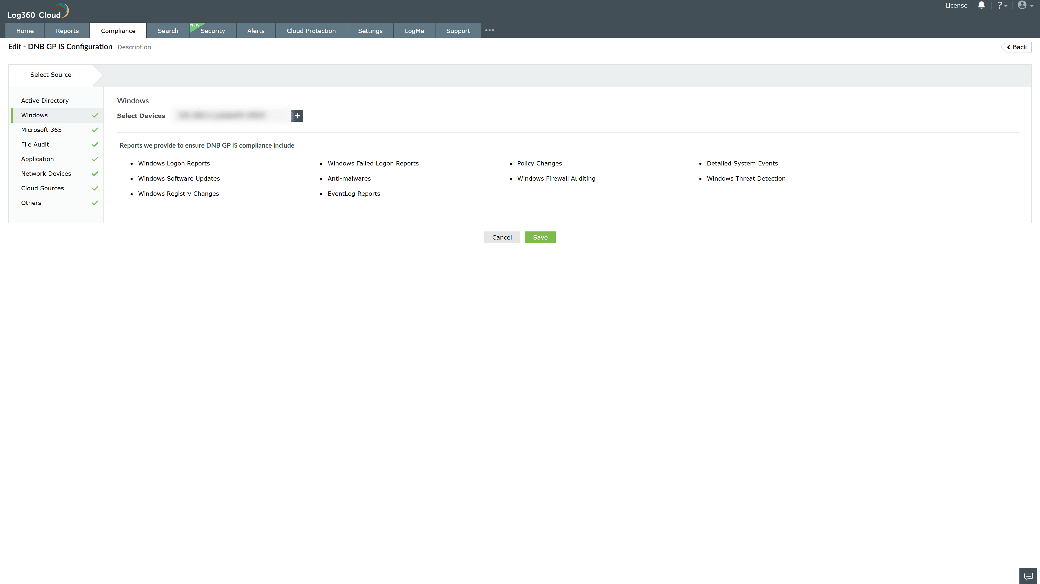

Valid Submission : Yes
Supported Editions : Free, Basic, Standard, Professional, MSSP
Help Document : https://www.manageengine.com/log-management/help/integrations/compliance-extensions.html
Help Video : Not provided
Tags : Log360, Compliance, Privacy monitoring, Data privacy, Regulatory compliance
Supported DCs : US, IN, JP, CA, AU, UK and EU
Privacy Policy:
Terms of Service:
Release Notes:
Predefined reports for the DNB GP IS Compliance.

